PARTE 1
Teoría
  - En no más de 15 renglones explique todo lo relacionado con objeto Vista.
  - En una carilla explique la Funcionalidad de Seguridad de un RDBMS detallando someramente los objetos relacionados con la misma.

Práctica
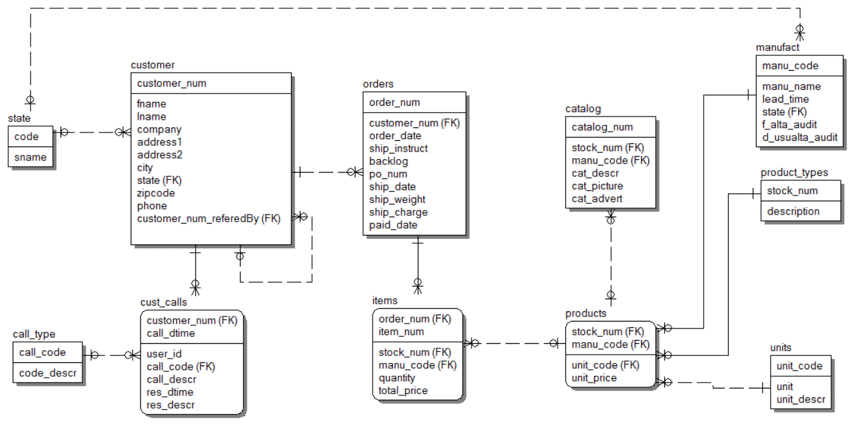
  - Crear una consulta que devuelva:
La siguientes cuatro atributos

Apellido, Nombre AS Cliente,
Suma de todo lo comprado por el cliente AS totalCompra,
Apellido, Nombre AS ClienteReferido,
Suma de lo comprado por el referido*0.05 AS totalComision

Consideraciones.
- En el caso que un no tenga OCs deberá mostrar 0 en el campo totalCompra
- En el caso que un Cliente no tenga Referidos deberá mostrar al mismo con NULL en las columnas ClienteReferido y totalComision.
- Para calcular la comisión del cliente se deberán sumar (cant*precio) de todos los productos comprados por el ClienteReferido cuyo stock_num sea 1,4,5,6,9. La comisión es del 5%.
- Se deberá ordenar la salida por el Apellido y Nombre del Cliente.

No se pueden utilizar tablas temporales, ni funciones de usuario.

SELECT c1.lname+', '+c1.fname AS CLIENTE,
COALESCE(SUM(i1.total_price*i1.quantity),0) AS totalCompra,
ref.lname+', '+ref.fname AS Referido,
ref.totalCompraReferido*0.05 AS totalComision
FROM customer c1 LEFT JOIN orders o1 ON (c1.customer_num=o1.customer_num)
LEFT JOIN items i1 ON (o1.order_num=i1.order_num)
LEFT JOIN (SELECT c2.customer_num, c2.lname, c2.fname,
SUM(i2.total_price*i2.quantity) AS totalCompraReferido,
c2.customer_num_referedBy
FROM customer c2 JOIN orders o2
ON (c2.customer_num=o2.customer_num)
JOIN items i2 ON (i2.order_num=o2.order_num)
WHERE c2.customer_num_referedBy IS NOT NULL
AND i2.stock_num IN (1,4,5,6,9)
GROUP BY c2.customer_num, c2.lname, c2.fname,
c2.customer_num_referedBy) AS Ref
ON (Ref.customer_num_referedBy=c1.customer_num)
GROUP BY c1.customer_num, c1.lname, c1.fname, Ref.customer_num,
Ref.lname, Ref.fname, Ref.totalCompraReferido
ORDER BY 1

SELECT c1.lname+', '+c1.fname AS CLIENTE,
COALESCE(SUM(i1.total_price*i1.quantity),0) AS totalCompra,
ref.lname+', '+ref.fname AS Referido,
ref.totalCompraReferido*0.05 AS totalComision
FROM customer c1 LEFT JOIN orders o1 ON (c1.customer_num=o1.customer_num)
LEFT JOIN items i1 ON (o1.order_num=i1.order_num)
Left join (select c2.lname, c2.fname, c2.customer_num_referedBy, SUM(i2.total_price*i2.quantity) as totalCompraReferido
from customer c2 LEFT JOIN orders o2 ON (c2.customer_num=o2.customer_num)
LEFT JOIN items i2 ON (o2.order_num=i2.order_num)
where i2.stock_num in (1,4,5,6,9)
group by c2.lname, c2.fname, c2.customer_num_referedBy) ref
on (c1.customer_num=ref.customer_num_referedBy)
group by c1.lname, c1.fname, ref.lname, ref.fname, totalCompraReferido
order by 1

select cliente.cliente, cliente.totalcompra, ref.referido, ref.totalReferido*0.05
from
( SELECT c1.customer_num, c1.lname+', '+c1.fname AS CLIENTE,
COALESCE(SUM(i1.total_price*i1.quantity),0) AS totalCompra
FROM customer c1 LEFT JOIN orders o1 ON (c1.customer_num=o1.customer_num)
LEFT JOIN items i1 ON (o1.order_num=i1.order_num)
group by c1.customer_num, c1.lname, c1.fname ) cliente left join
(select c2.lname+', '+c2.fname referido, c2.customer_num_referedBy, SUM(i2.total_price*i2.quantity) as totalReferido
from customer c2 LEFT JOIN orders o2 ON (c2.customer_num=o2.customer_num)
LEFT JOIN items i2 ON (o2.order_num=i2.order_num)
where i2.stock_num in (1,4,5,6,9)
group by c2.lname, c2.fname, c2.customer_num_referedBy) ref
on (cliente.customer_num=ref.customer_num_referedBy)
order by 1

PARTE 2
  - Stored Procedures

Desarrollar un stored procedure maneje la inserción o modificación de un producto determinado.
Parámetros de Entrada STOCK_NUM, MANU_CODE, UNIT_PRICE, UNIT_CODE, DESCRIPTION

Si existe el producto en la tabla PRODUCTS actualizar los atributos que no pertenecen a la clave primaria.
Si no existe el producto en la tabla PRODUCTS Insertar fila en la tabla, previamente validar lo siguiente:
- EXISTENCIA de MANU_CODE en Tabla MANUFACT - Informando Error por Fabricante Inexistente.
- EXISTENCIA de STOCK_NUM en Tabla PRODUCT_TYPES - Si no existe Insertar un registro en la tabla STOCK_NUM, si existe realizar UPDATE del atributo ‘description’.
- EXISTENCIA del atributo UNIT_CODE en la Tabla UNITS - Informando Error por Código de Unidad Inexistente.

create or alter Procedure Producto_PR @STOCK_NUM smallint, @MANU_CODE char,
@UNIT_PRICE decimal(6,2), @UNIT_CODE smallint,
@DESCRIPTION varchar as
begin
if exists (select 1 from products where stock_num = @STOCK_NUM and manu_code=@manu_code)
begin -- update
update products
set unit_price = @UNIT_PRICE,
unit_code = @UNIT_CODE
where stock_num = @STOCK_NUM and manu_code=@manu_code;
end
else -- es un insert
begin
if not exists (select 1 from manufact where manu_code = @MANU_CODE)
throw 50000, 'Fabricante INEXISTENTE', 1

if not exists (select 1 from units where unit_code = @UNIT_CODE)
throw 50000, 'Codigo de unidad INEXISTENTE', 1

if not exists (select 1 from product_types where stock_num = @stock_num)
insert into product_types (stock_num, description) values (@stock_num,@DESCRIPTION);
else
update product_types set description = @DESCRIPTION
where stock_num = @STOCK_NUM;

insert into products (STOCK_NUM, MANU_CODE, UNIT_PRICE, UNIT_CODE )
values (@STOCK_NUM, @MANU_CODE, @UNIT_PRICE, @UNIT_CODE);
end
end;

  - Triggers

Realizar un trigger de Insert sobre la siguiente Vista, insertando datos en las tablas correspondientes validando la existencia de sus respectivas claves primarias y que las mismas no sean NULAS.

CREATE VIEW v_Productos
(codCliente, nombre, apellido, codProvincia, fechaLlamado, usuarioId, codTipoLlamada, descrLlamada, descrTipoLlamada)
SELECT c.customer_num, fname, lname, state, call_dtime,
user_id, cc.call_code, call_descr, code_descr
FROM customer c JOIN cust_calls cc ON (c.customer_num=cc.customer_num)
JOIN call_type ct ON (cc.call_code=ct.call_code)
WHERE ct.call_code IN ('B','D','I','L','O')
AND state IN (SELECT code FROM state)
WITH CHECK OPTION

Tener en cuenta en el trigger la inserción de múltiples filas.

// Trigger version con Transaccion GLOBAL
CREATE or ALTER TRIGGER dbo.contactosTr
ON dbo.v_Productos
INSTEAD OF INSERT AS
BEGIN
--
declare @codCliente smallint
declare @nombre varchar(15)
declare @apellido varchar(15)
declare @codProvincia char(2)

declare @fechaLlamado datetime
declare @usuarioId char(32)
declare @codTipoLlamada char(1)
declare @descrLlamada varchar(40)
declare @descrTipoLlamada varchar(30)

DECLARE contactos_cur CURSOR FOR select * from inserted;
open contactos_cur;
--
begin try
FETCH NEXT FROM contactos_cur
INTO @codCliente, @nombre, @apellido, @codProvincia, @fechaLlamado,
@usuarioId, @codTipoLlamada, @descrLlamada, @descrTipoLlamada;

WHILE @@FETCH_STATUS = 0
BEGIN
if not exists (select 1 from dbo.customer c
where c.customer_num = @codCliente)
insert into customer (customer_num, fname, lname,state)
values (@codCliente, @nombre, @apellido, @codProvincia)

if not exists (select 1 from call_type ct
where ct.call_code = @codTipoLlamada)
insert into call_type (call_code,code_descr)
values (@codTipoLlamada, @descrTipoLlamada)

insert into cust_calls (customer_num, call_dtime, user_id,
call_code, call_descr)
values (@codCliente, @fechaLlamado, @usuarioId,
@codTipoLlamada, @descrLlamada)

FETCH NEXT FROM contactos_cur
INTO @codCliente, @nombre, @apellido, @codProvincia, @fechaLlamado,
@usuarioId, @codTipoLlamada, @descrLlamada, @descrTipoLlamada;
END
end try
begin catch
rollback;
print 'Nro. Error:' + cast(ERROR_NUMBER() as varchar);
print 'mensaje:' + ERROR_MESSAGE();
end catch
CLOSE contactos_cur
DEALLOCATE contactos_cur
END

- Trigger en versión con TRANSACCIONES por fila

CREATE or ALTER TRIGGER dbo.contactosTr
ON dbo.v_Productos
INSTEAD OF INSERT AS
BEGIN
--
declare @codCliente smallint
declare @nombre varchar(15)
declare @apellido varchar(15)
declare @codProvincia char(2)

declare @fechaLlamado datetime
declare @usuarioId char(32)
declare @codTipoLlamada char(1)
declare @descrLlamada varchar(40)
declare @descrTipoLlamada varchar(30)

DECLARE contactos_cur CURSOR FOR select * from inserted;
open contactos_cur;
--
FETCH NEXT FROM contactos_cur
INTO @codCliente, @nombre, @apellido, @codProvincia, @fechaLlamado,
@usuarioId, @codTipoLlamada, @descrLlamada, @descrTipoLlamada;
--
WHILE @@FETCH_STATUS = 0
BEGIN
if @@TRANCOUNT <= 0 -- si ya esta seteada la transaccion, no la creo
begin transaction;
begin try
if not exists (select 1 from dbo.customer c where c.customer_num = @codCliente)
insert into customer (customer_num, fname, lname,state) values (@codCliente, @nombre, @apellido, @codProvincia)

if not exists (select 1 from call_type ct where ct.call_code = @codTipoLlamada)
insert into call_type (call_code,code_descr) values (@codTipoLlamada, @descrTipoLlamada)

insert into cust_calls (customer_num, call_dtime, user_id, call_code, call_descr)
values (@codCliente, @fechaLlamado, @usuarioId, @codTipoLlamada, @descrLlamada)
commit tran;
--
end try
begin catch
rollback tran;
print 'Nro. Error:' + cast(ERROR_NUMBER() as varchar);
print 'mensaje:' + ERROR_MESSAGE();
end catch
FETCH NEXT FROM contactos_cur
INTO @codCliente, @nombre, @apellido, @codProvincia, @fechaLlamado,
@usuarioId, @codTipoLlamada, @descrLlamada, @descrTipoLlamada;
END
CLOSE contactos_cur
DEALLOCATE contactos_cur
END

Parte 1 |  |  |  | Parte 2
a | b | c |  | d | e
Nota |  |  |  | Nota

